MEGHNAD SAHA INSTITUTE OF TECHNOLOGY

*Techno Complex, Madurdaha,Beside NRI Complex, Post-Uchhepota, Kolkata 700 150*

LABORATORY NOTE BOOK

MAKAUT ODD SEMESTER 2024



[MASTER OF COMPUTER APPLICATION]

[RELATIONAL DATABASE MANAGEMENT SYSTEM LAB (MCAN192)]

[RUPAK SARKAR]

ROLL NO: 14271024036 REGN. NO.: 241420510045

STREAM: MCA SEMESTER: I (1ST)

YEAR: 1ST YearSESSION: 2024-2026



MAULANA ABUL KALAM AZAD UNIVERSITY OF TECHNOLOGY



MEGHNAD SAHA INSTITUTE OF TECHNOLOGY

*Techno Complex,. Madurdaha,Beside NRI Complex, Post-Uchhepota, Kolkata 700 150*

“LIST OF ASSIGNMENT/EXPERIMENT SUBMISSION DETAILS”

|  |  |  |  |  |  |
| --- | --- | --- | --- | --- | --- |
| **SL.**  **NO.** | **ASSIGNMENT / EXPERIMENT NAME** | **DATE OF EXPERIMENT** | **DATE OF SUBMISION** | **CHECKED BY** | **REMARKS (ANY DEVIATION REGARDING SUBMISSION DATES, CONTENT, FORMAT, ETC)** |
|  |  |  |  |  |  |
|  |  |  |  |  |  |
|  |  |  |  |  |  |
|  |  |  |  |  |  |
|  |  |  |  |  |  |
|  |  |  |  |  |  |
|  |  |  |  |  |  |
|  |  |  |  |  |  |
|  |  |  |  |  |  |
|  |  |  |  |  |  |

|  |
| --- |
| OBSERVATIONS / COMMENTS ON THE OVERALL PERFORMANCE: |

Signature in full with date Signature in full with date

**Faculty / Technical Assistant Lab Examiner**

**Q. Create a table called EMP with the following structure:  
(EMP_NO, E_ADDRESS, E_PH_NO, DEPT_NO, DEPT_NAME, JOB_ID, DESIGNATION, SALARY)**

Ans: To create the abovementioned table, we write the following command –

**SQL Query –** CREATE TABLE EMPLOYEE2(EMP_NO NUMBER(5), E_NAME CHAR(15), E_ADDRESS VARCHAR2(30), E_PH_NO NUMBER(10), DEPT_NO NUMBER(5), DEPT_NAME VARCHAR2(10), JOB_ID VARCHAR2(10), DESIGNATION VARCHAR2(15), SALARY NUMBER(10,2), HIRE_DATE DATE); 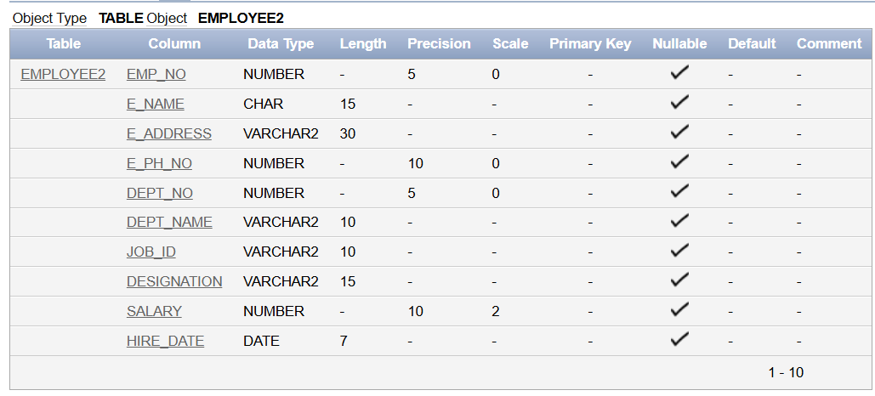

**Q.1. List the E_no, E_name, Salary of all employees working for MANAGER.**

Ans: To list the E_no and E_name, we need to write the following query.

**SQL Query –** SELECT EMP_NO, E_NAME, SALARY FROM EMPLOYEE2 WHERE (DESIGNATION='MANAGER');

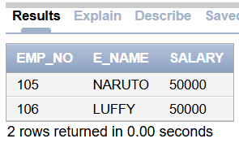

**Q.2. Display all the details of the employee whose salary is more than the Sal of any IT**

**PROFF.**

Ans: To display all the details of the employee whose salary is more than the Sal of any IT Proff, we need to write the following query.

**SQL Query –** SELECT * FROM EMPLOYEE2 WHERE SALARY>(SELECT MAX(SALARY) FROM EMPLOYEE2 WHERE DESIGNATION='ITPROFF');

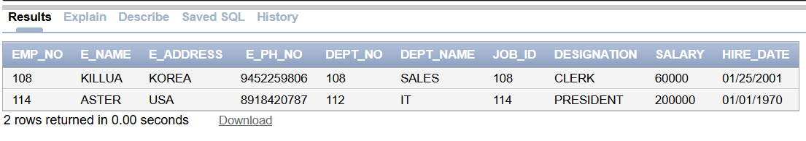

**Q.3. List the employees in the ascending order of Designations of those joined after**

**1981.**

Ans: To list the employees in the ascending order of Designations of those joined after

1981, we need to write the following query.

**SQL Query –** SELECT * FROM EMPLOYEE2 WHERE HIRE_DATE>'01/01/1981' ORDER BY DESIGNATION;

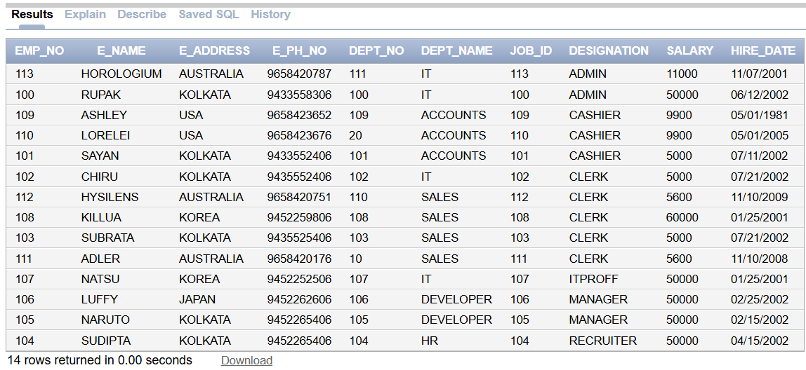

**Q.4. List the employees along with their Experience and Daily Salary.**

Ans: To list the employees along with their Experience and Daily Salary, we need to write the following query:

**SQL Query –** SELECT E_NAME, (SYSDATE-HIRE_DATE)/365 AS EXPERIENCE, (SALARY/30) AS DAILY_SALARY FROM EMPLOYEE2;

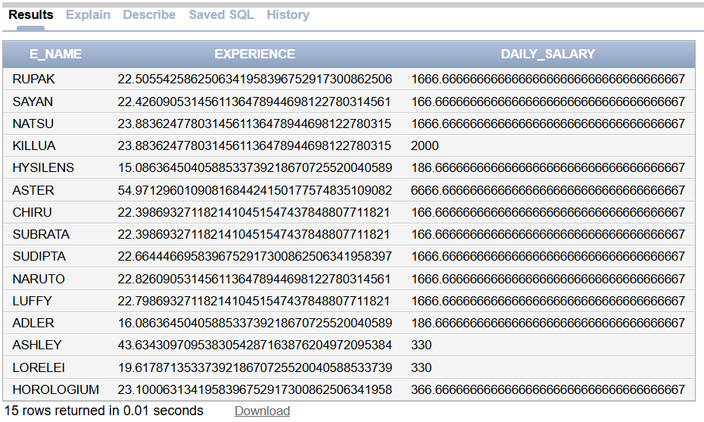

**Q.5. List the employees who are either ‘CLERK’ or ‘ANALYST’.**

Ans: To list the employees who are either ‘CLERK’ or ‘ANALYST’, we need to write the following query:

**SQL Query –** SELECT * FROM EMPLOYEE2 WHERE DESIGNATION=('CLERK') OR DESIGNATION=('ANALYST');

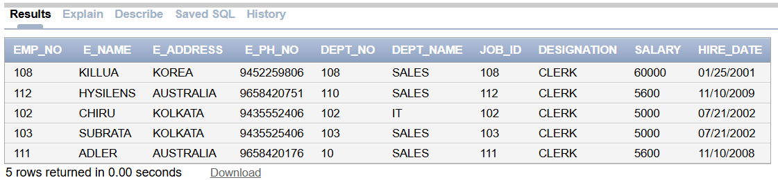

**Q.6. List the employees who joined on 1-MAY-81, 3-DEC-81, 17-DEC-81,19-JAN-80.**

Ans: To list the employees who joined on 1-MAY-81, 3-DEC-81, 17-DEC-81,19-JAN-80, we need to write the following query:

**SQL Query –** SELECT * FROM EMPLOYEE2

WHERE HIRE_DATE IN (

TO_DATE('01-05-1981', 'DD-MM-YYYY'),

TO_DATE('03-12-1981', 'DD-MM-YYYY'),

TO_DATE('17-12-1981', 'DD-MM-YYYY'),

TO_DATE('19-01-1980', 'DD-MM-YYYY')

);

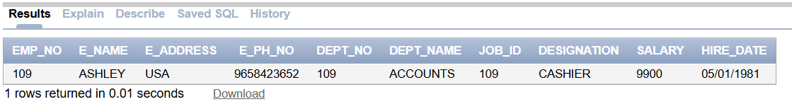

**Q.7. List the employees who are working for the Dept_no 10 or 20.**

Ans: To list the employees who are working for the Dept_no 10 or 20, we need to write the following query:

**SQL Query –** SELECT * FROM EMPLOYEE2 WHERE DEPT_NO IN (10, 20);

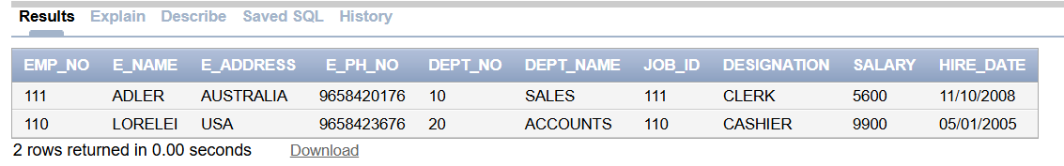

**Q.8. List the E_names those are starting with ‘S’.**

Ans: To list the E_names those are starting with ‘S’, we need to write the following query:

**SQL Query –** SELECT E_NAME FROM EMPLOYEE2 WHERE E_NAME LIKE 'S%';

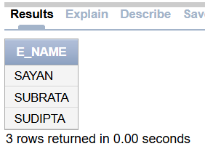

**Q.9. Display the name as well as the first five characters of name(s) starting with ‘H’.**

Ans: To display the name as well as the first five characters of name(s) starting with ‘H’, we need to write the following query:

**SQL Query –** SELECT E_NAME, SUBSTR(E_NAME, 1, 5) AS FIRST_FIVE_CHARS FROM EMPLOYEE2 WHERE E_NAME LIKE 'H%';

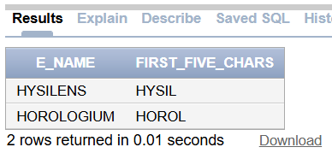

**Q.10. List all the emps except ‘PRESIDENT’ &amp; ‘MGR” in asc order of Salaries.**

Ans: To list all the emps except ‘PRESIDENT’ &amp; ‘MGR” in asc order of Salaries, we need to write the following query:

**SQL Query –** SELECT * FROM EMPLOYEE2 WHERE DESIGNATION NOT IN ('PRESIDENT', 'MGR') ORDER BY SALARY ASC;

